Shingle Springs-Ponderosa FFA
Chapter Officer Application
2016-2017 School Year
Guidelines:
- All officer positions are open to any second and third year agriculture student with a minimum of a G.P.A of 2.00 with no D’s or F’s in any of your current classes.

- President position shall be open to any student currently holding the Chapter FFA Degree.

- Be familiar with general FFA knowledge (i.e. FFA Motto, FFA Mission Statement, 3 Circles of Ag Education).

- You must either possess or will have earned by the end of your term, your Chapter FFA Degree. You must also have your own FFA jacket or plans to be purchasing one by the end of the school year.

- Chapter Officers will be given an officer contract that covers their individual responsibilities they will be obligated to honor. Disciplinary action will be based on individual issues if needed.

- Chapter Officers will be participating in activities at the local, sectional, regional and state level and are expected to maintain pride and dedication through their school and personal actions.

- Chapter Officers are expected/required to take Ag Leadership class the year that they are serving in office.

- Fill out the attached application, have your parents sign and date it, and return it no later than Friday April 1st by 3pm!
Answer each question as honestly as possible and be sure to use complete sentences.

- Interviews will be held on Sunday April 10th starting at 9am in the Ag Dept. Interviews will last all day, all candidates will need to arrive at 9am as interviews will include group activities.

- The officer nominees will be announced immediately following interviews.

- You are required to attend the April meeting and give a one minute impromptu-style speech on your given topic. You will also have a chance to speak to members at a meet and greet at the conclusion of this meeting. You may prepare one 8x12 flyer for this meet and greet.

- You are required to give a speech in support of your nomination. It will be videotaped on Monday May 4 or Wednesday May 6, after school and will be shown to all the agriculture classes the following days. There will be a sign up list for recording times when the officer slate is announced after interviews. Your speech needs to be a maximum of 2 minutes in length, must be recorded in the Ag Department, and you are allowed to bring/use props as needed for your speech. You will need to be practiced and prepared on filming day as you will have a maximum of 15 minutes to record your speech.

- Officer Speeches will be shown and voting will take place on Friday, May 13 in Agriculture classes. Individual phone calls will be made to candidates to inform them if they have been selected as an officer.

Name: _____________________________________ Grade in school: ________
On a separate sheet of paper please type your answers. Be sure to answer completely and use complete sentences. PLEASE ATTACH A PHOTO OF YOURSELF (preferably in official dress).

- Describe the qualities you possess that make you an ideal candidate for chapter office.

- What are the top three FFA Activities that you have participated in and what have you learned from each of them?

- Review the officer duties and then mark the 2 offices that you feel most qualified for (remember presidency is not open to current freshmen).

President _____ Reporter _____
Vice President _____ Sentinel _____ Secretary _____ Historian _____
Treasurer _____ Recruitment _____

- What would you like to do to make the Ponderosa FFA Chapter stronger and more successful in the future? Please be specific in explaining your ideas.

- What are some potential conflicts that may present challenges to you while serving as an officer - sports, job, school, AP classes, grades, transportation, etc.? Please list them in detail. Please explain how you plan to balance your commitments with FFA and your other activities. Please rank your priorities from highest to lowest.

- Please give the attached survey to a teacher, counselor, or school officer (not an Ag teacher) to have them fill. Surveyors must return the form directly to Ms. Adams by April 1st. Surveys returned by candidates will not be accepted.

- You will be required to attend a MANDATORY officer retreat this summer. This will occur during the month of July. It is extremely important to building a team that each officer is in attendance. This will be a great teambuilding session as well as set the theme and the tone for the rest of the year. Please verify that you be able to attend this retreat.
There will also be the expectation to attend the Chapter Officer Leadership Conference which will take place October 1-2, and winter retreat planned during the end of winter break for 2-3 days.

Parents – Thank you for supporting your student in their choice to make a difference in the FFA! It will be an exciting and challenging school year. They are required to attend the officer retreat this summer and each month an officer meeting is held at a different student’s home. Do you foresee any problems with your student being an officer, attending the retreat, or hosting one of the monthly FFA meetings at your home? Please include a separate statement if there is an issue or concern with any of these or with any questions or concerns about events or officer responsibilities and expectations.

Address_________________________________ Cell Phone #_____________________________

________________________________________ E-mail address: _________________________________

Parent Name and Home Phone number: ________________________________________________________

_______________________________________ Date __________________
Student Signature

________________________________________ Date___________________
Parent or Guardian Signature
SURVEY OF CHAPTER OFFICER CANDIDATE'S QUALIFICATIONS
To the Candidate:
The Chapter Officer Candidate Survey of Qualifications is a confidential document that should be submitted privately by a school teacher, counselor, administrator, or other school official. Place indicate who the survey has been completed by. Next, deliver this form to the individual who will be completing it. Remember, only one survey must be submitted on your behalf. Remind the survey completer that this form must be delivered directly to Ms. Adams. In any event, you should check back with each survey completer to be certain the form is delivered by April 1st.
Candidate's Name: _____________________________________________________

Survey Completed By: Teacher___ Counselor___ Administrator___ Other:_____________

To the Survey Completer:
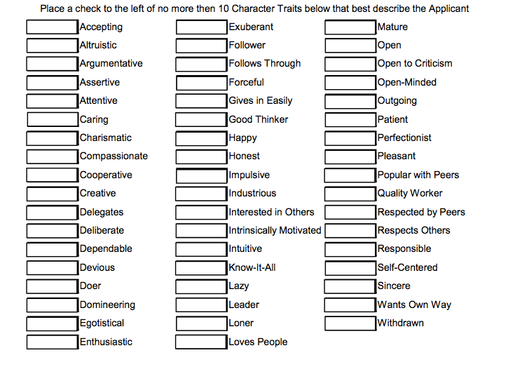
Your responses to this survey are extremely important. The information you provide will have a direct impact on this individual's bid for office in the Ponderosa FFA Chapter. Chapter FFA Officers play a significant role in guiding and operating our chapter’s program. We genuinely appreciate your participation and cooperation in this process. The Chapter FFA Advisor and Nominating Committee are the only individuals who will see this survey. We ask that you are completely open, honest, and thorough with your responses.
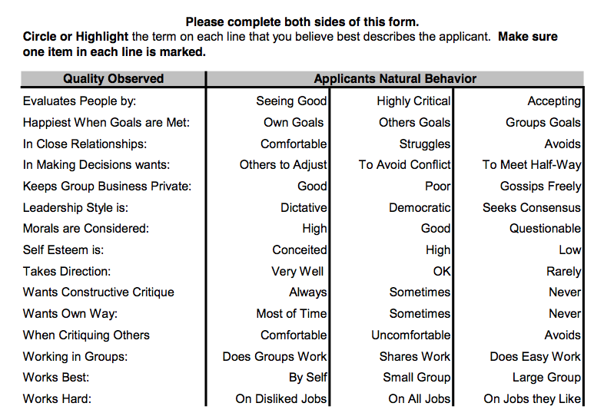
Comments:
Record here any information which you believe would be valuable in helping the committee know more about and accurately evaluate the candidate.

Recommendation:
Would make an Excellent Chapter Officer Candidate: ________
I have concerns/reservations regarding this candidate: ________
Should not be elected to Chapter Office: ________
Name of Survey Completer:________________________________________________
Survey Completer Signature:_______________________________________________

